CS 2050 Technical Documentation

General Resources
Development Environment
Git and GitHub
Eclipse IDE
Module 1: Language Fundamentals
Parts of a Java Program

General Resources
Your first source should always be:
- Your class lecture slides, documents and the resources linked in the canvas materials, instructor (Deb), learning assistant (LA)

Tools:
- Visualize Java Code - used to step through code and edit code

Feel free to add more resources shared from the lectures.

Development Environment

Version Control
A system that tracks and manages changes to files over time. A software tool that organizes every version I create, like code. It keeps a history of changes where it allows me to revert to previous versions. Each version is an update of the file or code.

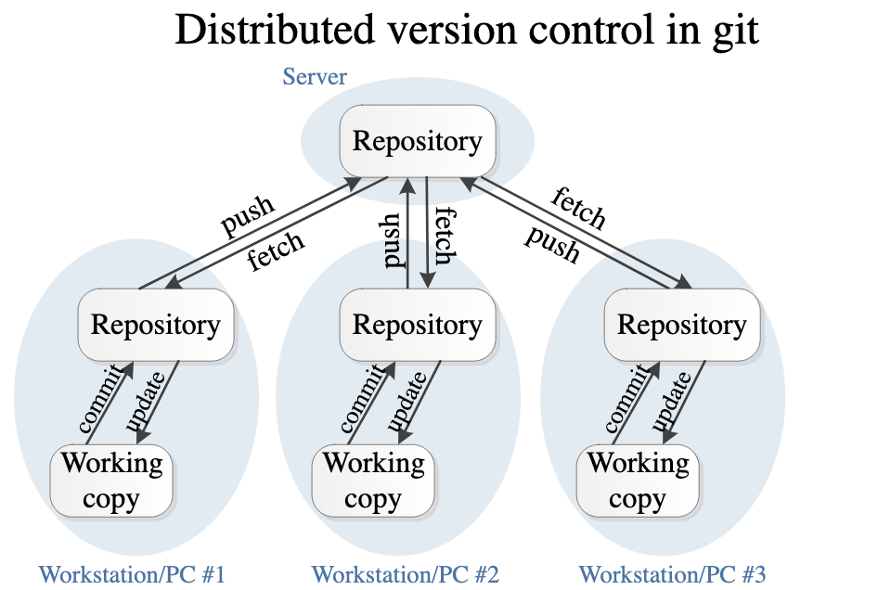
https://www.google.com/url?sa=i&url=https%3A%2F%2Fhomes.cs.washington.edu%2F~mernst%2Fadvice%2Fversion-control.html

Integrated Development Environment (IDE)
A Software application that provides programmers all the tools for software development: debugger, write code, build automation tools (compile and run projects), and most have syntax highlighting. For example: Eclipse, Visual Studio Code (VS), PyCharm, NetBeans, Xcode, etc.

Git and GitHub
Git and Github are different but related tools used in software development for version control and collaboration.

Git
- Version control system
- Track changes of codes and other files over time
- Let’s you go back to projects if needed
- Works offline

GitHub
- Stores Git repositories online, making them accessible with others
- Provides collaborations tools (pull requests for code view, issues, project boards)
- Needs internet to use
- GitHub is a service that hosts Git repositories

- Local git repo with Screenshot of your local git repository folders and files
- github desktop version control steps with commands and their description
- Github remote repository with screenshot of Eclipse Project Folder and java files
- Gitignore file
- Resource List to help you

Eclipse IDE
Summarize Eclipse and include resources that will help you use eclipse.

Module 1
Note* Algorithm: set of steps to complete a task. An algorithm can be used to solve a problem.
An Algorithm has 3 main parts.
- Input: Having data or information to give to the algorithm.
- Process: A series of logical and arithmetic steps that the algorithm performs on the input.
- Output: The results or conclusion that the algorithm produces after completing its process.

How is Information Stored in Memory?
Note: In computer systems, it has two types of memory: Stack and Heap. These are distinct memory that serve different purposes and characteristics of how information can be stored and accessed.

Stack Memory
…

Heap Memory
…

Classes
Classes are constructs that define objects with the same data type. A class also provides “special” types of methods, known as constructors, which are invoked(initiate execution of a function like a method.) to construct objects from the class.
- Class is not a real world entity. It is only a blueprint or prototype from which objects are created.
- Class can have groups of variables of different types…
- Class can have variety of methods to define behaviors
- A class is a plan that defines common attributes and behaviors that all the objects created from it will share.

Objects
An object that is created as an instance from a class. An object has two important pieces.
- Behavior
- Things an object does
- Methods that operate on the object
- For instance, a “car” object may have behaviors like lock doors, honk, turn on/off engine and lights, brake, accelerate, etc.
- State
- Things an object knows
- The data fields (attributes) that define an object
- For example, a “car” object may have attributes like color, model, year, gear, fuel level, etc.

Encapsulation
Use encapsulation to hide data within the class.

How to do this?
- Declare variables as privates (Private instance variables)

What happens?
- Can no longer be accessed outside of the class.
- These variables are hidden and can only be used inside the class.
- Provide getters/setters to access/modify variables.
- Getter: Method that Returns the value of an instance variable
- Setter: Method that Sets the value of an instance variable

Constructors
Constructors can be used to initialize values to the data member fields of a class when creating an object.
- A constructor has the exact name as the class
- A constructor can overload, meaning it can hold multiple constructors with different parameters
- There is no return type. Including void.
- It is not necessary to write a constructor in a class

Instance Variables & Instance Methods

Instance Variable
- A variable that is part of an instance within a class
- State of an object: things an object knows about itself
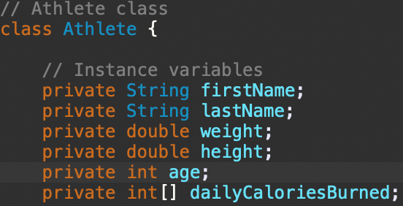
This screenshot shows instance variables for being created in a class.
*Why make it private? So no other programmer can change the objects

Instance Method
- A method that is part of an instance of a class
- These can only be executed through a reference to an instance
- Behavior of an object: things an object can do
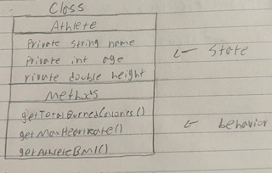

Arrays (1D)
An array is a data structure that provides storage for more than one value, but they must be the same data type.

- An array can access that set of values through one variable name
- Store fixed set of values of the same type
- 1D array is a single row that a list of elements of the same type is stored

Example:
Index: 0 | 1 | 2 | 3 | 4
Value: 1 9 3 82 273
Element: 1 2 3 4 5

2D Arrays
A two-dimensional array is like a table, matrix or spreadsheet that are arranged in rows and columns.
- Has two brackets “[][]” to be declared as a 2d Array
- First bracket is rows, second bracket is columns, “[3][4]”
- A 2D array has an array inside of an array!

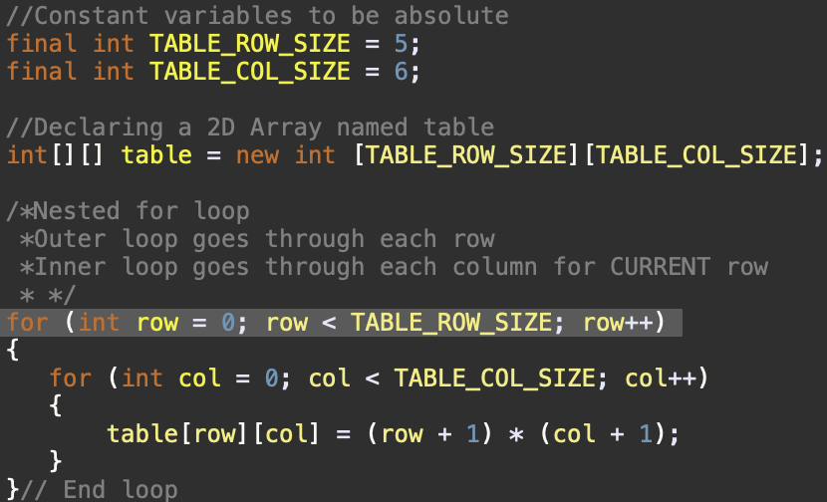

*Note: Null is the default value that is stored in index when a reference is not initialized
Arrays are stored CONSECUTIVELY

Initialize an Array
…

Static (Class) Variables
A static variable is a variable that is shared by all objects of a class. In other words, a variable that is shared among all objects of the class which means there is only one copy of it in memory.
- Declared with the keyword static.
- Shared with all instances of the class, meaning that there is only one copy of it in memory.
- Can be accessed by using the class name, no objects necessary.
- Static variables are also called Class variables, vise versa.

Static (Class) Methods
A method that is shared by all objects of a class.

- It is declared with the static keyword! Hence it is a static method
- It can be executed without needing to reference an instant of the class
- Using a method that is static can be called directly by using the class name
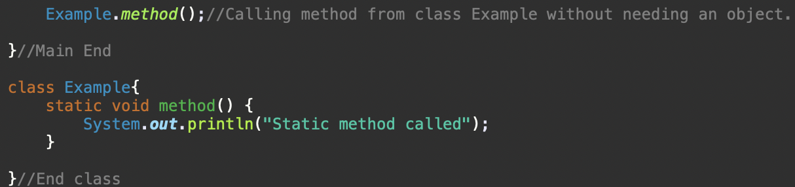
- Does not need an object to call static method

Instance vs Static

Instance method
Needs an object’s data to work.
- This belongs to an object
- To make a call it needs an object reference
- Ex: Book1.getTittle()
- Needs an instance or static variables to be able to access

Static method
Needs class’ data or parameters to work. No objects.
- This belongs to the class
- To make a call it needs the Class name
- Ex: Shelf.getTotalBooks()
- Only needs static variables directly

____________________________________________________________________________

Module 02

Sorting Arrays (1D Array)
Sorting arrays arranges the list of elements in a specific order. Helps organize data for easier access and analysis.

- Selection sort - A sorting algorithm that works by repeatedly selecting the smallest or largest value, one at a time, from the unsorted part of an array and swapping it with the first unsorted value.
- Bubble sort - A sorting algorithm that works by repeatedly comparing elements adjacent in the list and their sorted positions are swapped if they are in the wrong order.
*We don’t use bubble sort
- Insertion sort - A sorting algorithm that works by inserting a value into its correct position, one at a time, within the sorted portion of the list

Selection Sort

Visualization
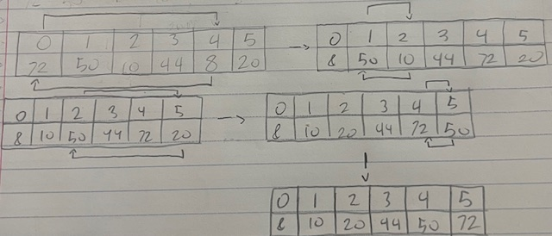
An example to see how the selection sort works in the process of sorting the elements from smallest to biggest.

Algorithm
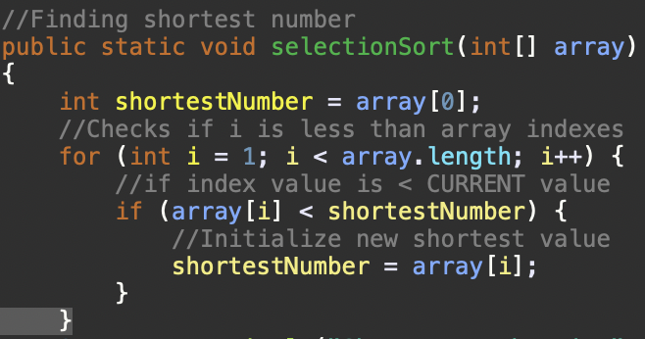
This code will find the shortest number in an array by selecting each index one at a time.
*Does not swap.

Test Driven Development

Summary
- Break problems into smaller pieces.
- Design test cases to help understand logical thinking.
- Precondition (input)
- Process
- Post-condition (output)
- Implement each algorithm and test before implementing the next. One step at a time.
- Refactor following Single Responsibility Principle (SRP) & Do not Repeat Yourself (DRY)

TDD Design
(Image here)

Linear Search (Sequential Search)
A simple algorithm that starts at the beginning of an array and looks for a specific value in a list by checking each element at a time until it finds its match.
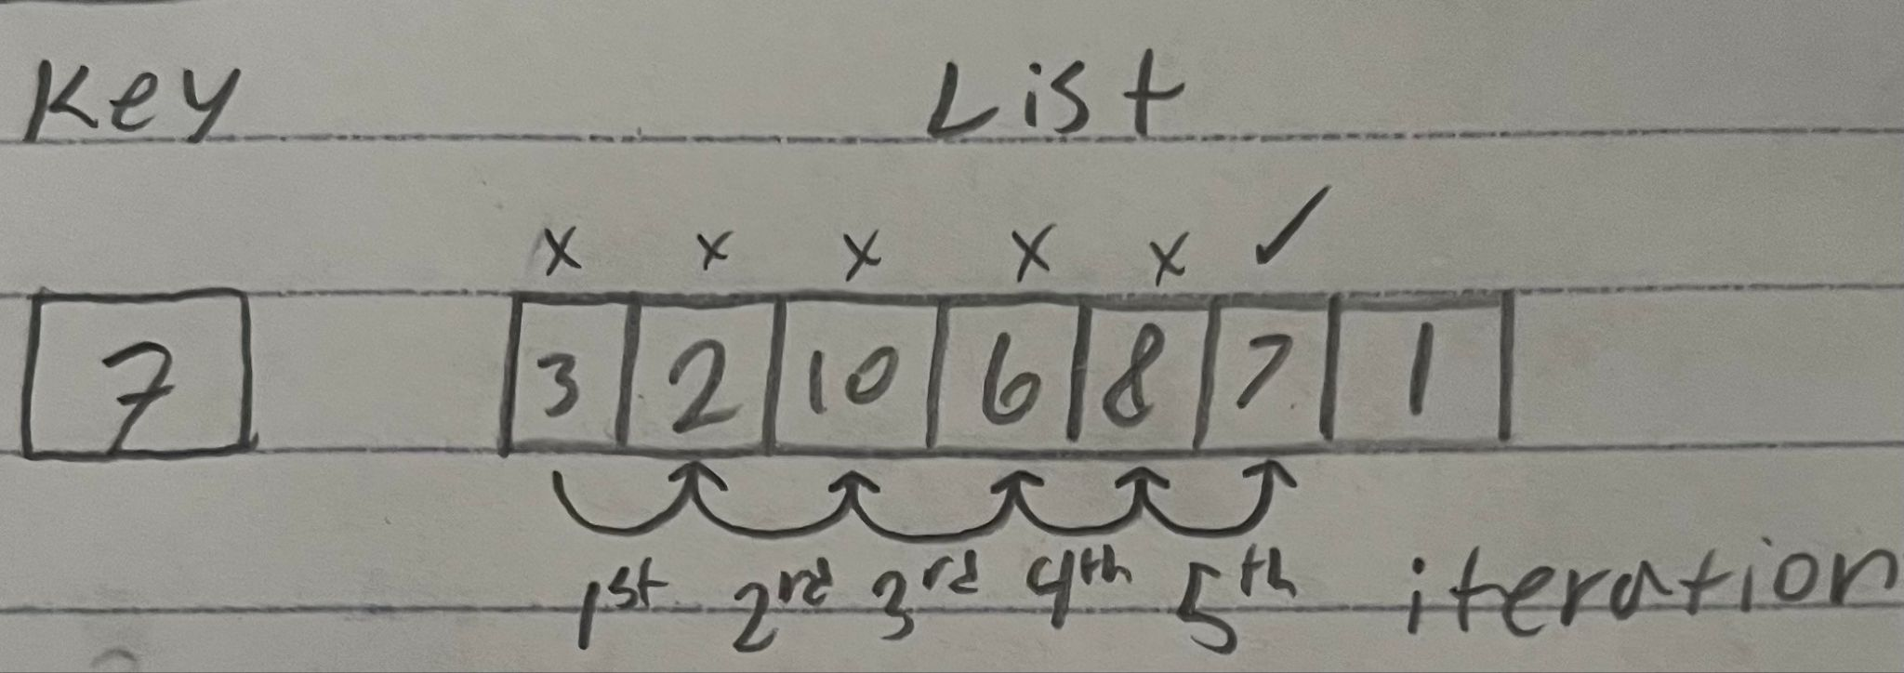
- Starts at 0(3) of an array and looks for a certain value at one element at a time in any order.
- When a match (7) is found, that index of the match is returned. A -1 is returned.
- In most cases it is not a very efficient algorithm.
- Best case: 1st element is key or near start at the beginning
- Middle case: key is somewhere in the middle of the list
- Worst case: last element or key is not found
- Linear search is best for Unsorted Array
- Code: for (int i = 0; i < list.length; i++) {
If (key == list[i]) {
return i; }
return -1; }

Binary Search
Another algorithm approach than linear search, but requires the elements in an array to be ordered before the search begins.

What does this algorithm do?
- Starts at the middle element of the array
- If key is less than middle element, only search key in 1st half of array.
- If key is equal to middle element, return match.
- If key is greater than middle element, only search key in 2nd half of array.
- More efficient algorithm–array shrinks by 50% after each comparison
- Binary search is best for Sorted Array
- Code: while (high >= low) {
int mid = (low + high) / 2; //finds middle
if (key < list[mid])
high = mid - 1;
else if (key == list[mid])
return mid;
else
low = mid + 1;

Linear vs Binary Search

Linear Search
- Search algorithm in which each element in the list is compared to a certain key starting at the beginning and comparing that key with each element sequentially until it is matched.
- Good for small and unsorted arrays.

Binary Search
- Searching a presorted array by splitting the array in half on each comparison.
- Good for large arrays that are presorted
Note: pre-sorted array is an array that is already arranged in a specific order before applying any sorting algorithm.

Note distinction between both searched:
If you double the array size, how does the number of comparisons in binary search change compared to linear search?

If doubling the array size, the number of comparisons in Binary search changes to 1 more comparison because the algorithm cuts the remaining search comparison in half. In contrast, linear search will have to double the comparisons since it checks every element.

Rating Algorithms
Why does one search feel instant and another takes forever? (credit for Debs, I like this :))

Some algorithms are either faster or slower than others.
A way to measure speed that doesn’t depend on the computer is Big-O

Big-O is a rating system for algorithms
- I believe it is a mathematical method that is used to estimate and rank algorithms based on their speed, efficiency and performance.

Big-O
- A theoretical mathematical concept that analyzes algorithms describing how the runtime of an algorithm grows as the input size grows as well.
- Gives us an upper-bound on the growth rate behavior of an algorithm. Which describes the worst-case efficiency of an algorithm.
- A rating system for algorithms.
- The rating tells us how fast an algorithm changes to be as the number of inputs gets bigger and bigger.

Big-O Symbols
O() is “order of” = How fast or slow an algorithm grows as input grows.
n = The size of the input (number of items an algorithm has to work with).

Best to Worst Cases:
- O(1) → Constant, 1 step (always takes the same amount of steps, regardless of how large the input is).
- O(n) → Linear, grows along with input (9456 input, 9456 comparisons. If input doubles, comparisons double as well).
- O(log n) → Logarithmic, grows very slowly (As input grows, steps grow very slowly).
- O(n^2) → Quadratic, Steps grow like a square (If input doubles, work grows 4 times).
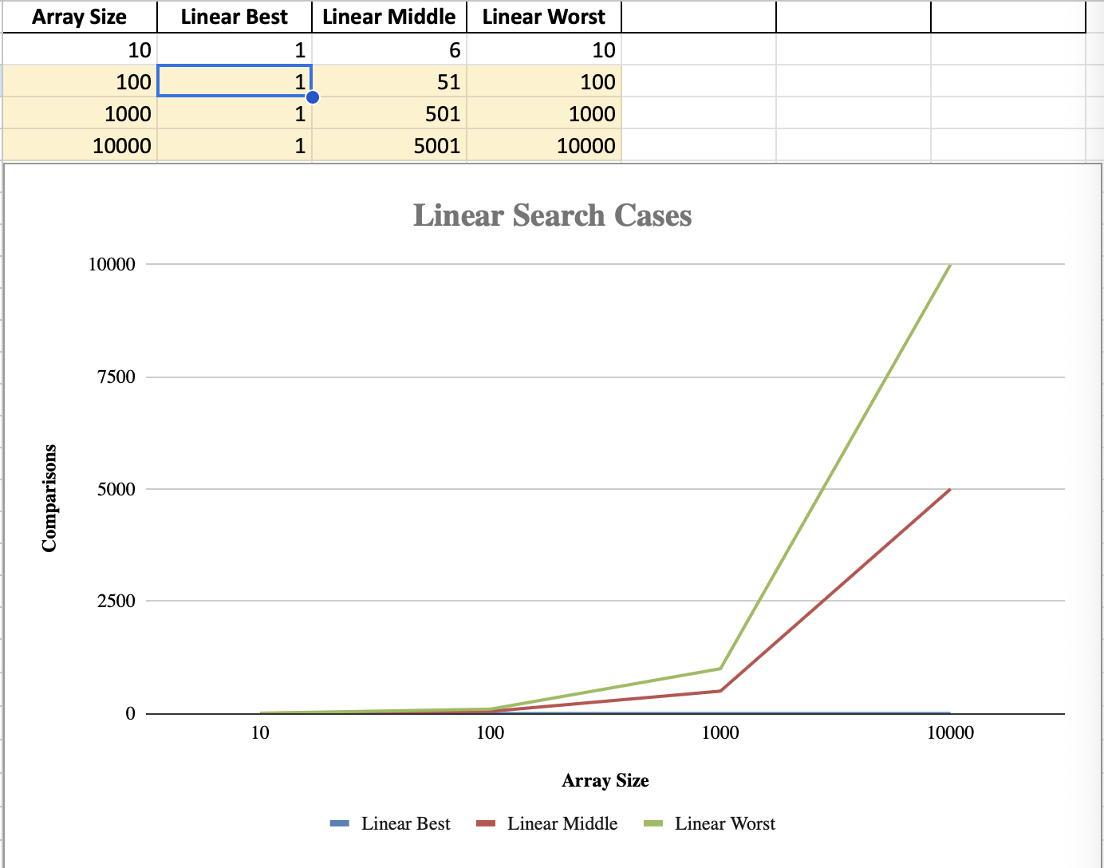
Linear best - is a O(1) because it doesnt grow and remains on 1.
Linear middle - is a O(n) Grows linearly, divides the number of array size by 2 that remains in the middle of the list
Linear worst - Also a O(n) Grows faster, meaning it must check every element to the array size.

Class Relationships
Three kinds of relationships between classes in Object-Oriented Programming that objects work together.

Association
Association: One class knows about another. Best to think about this as “uses-a” or “knows-a” relationship.
A relationship between two classes that have no connection, meaning they exist independently with their own data.
Example: A student borrows a library book. They are connected, but not owned by each other.
Association is the weakest relationship since there is only a reference between classes and not ownership.

Aggregation
Aggregation: One class has another, but the parts can exist independently. This is a weak “has-a” relationship.
Example: A library has books, but books can exist outside of the library or move books to a different library location

Composition
Composition: A solid “owns-a” relationship, This is quite the opposite of an aggregation relationship, If the container goes away, the parts go away as well. Best to think of a strong “has-a” relationship
Example: If a gym creates the rules itself, the gym owns them completely.

Inheritance
Inheritance is an OOP concept that allows a subclass (child class) to reuse code from a superclass (parent class). The superclass contains information such as, methods and variables that the subclass can use. To do this, the superclass inherits → the subclass to access and reuse it’s field without rewriting code. This is a one-way relationship between the two classes.
- Use “extend” for other classes to access superclass.
- This inherits from the superclass’s info.
- This is a “IS-A” relationship
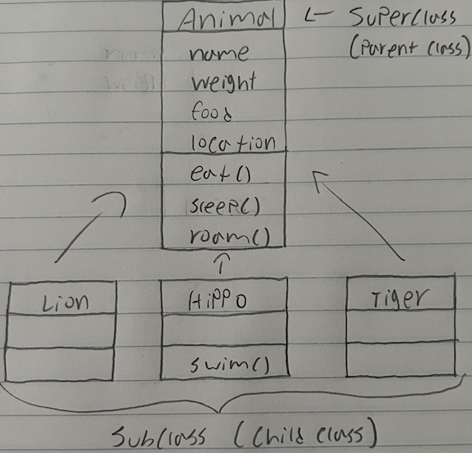
Lion, Hippo, and Tiger inherits from Animal, meaning that the Animal class contains functionality, then the subclass will automatically get the same functionality.

Inheritance “Is-A” relationship
Superclass (parent class)
- Contains common properties and behaviors.
Subclass (child class)
- A class that extends another class directly or indirectly.
- Inherits accessible data fields (instance variables).
- Also known as extended class and derived class.
Method overriding
- When a subclass modifies (changes) the implementation of a method in its superclass.

Superclass Constructor
Means that the subclass that is inheriting can use accessible data fields and methods from the superclass. But constructors are not inherited by the subclass.
- Cannot directly call a supperclass constructor.
- Although superclass constructors can be invoked explicitly or implicitly
- Access Explicitly: use the super keyword
- Access Implicitly (automatically): Superclass’s default constructor is automatically invoked if keyword super is not explicitly used.

toString() Method
A toString() method is a method that returns a string that describes an object.

A default implementation returns a string that contains:
- Class name of which the object is an instance.
- And the object’s memory address (unique id) that are numbers representing it.
- Example: Spider@798a439
- Not useful.

Inheritance and Overriding
Method overriding is when a method is defined in a child class that matched a method defined in a parent class.
- The child class method must match the method signature and return type of the method in the parent class
- @Override is an annotation to indicate that the child class method is over-writing the parent class method.

Overriding
When a method is defined in a child class that matches a method defined in a parent class.

without using overriding, this means that the behavior is not going to change in the subclass that got inherited from the super class to use its information. On the other hand, using overriding in the subclass means that the behavior changes when it is meant to perform a different action from the super class, but using the same method.

- Instance methods can be overridden, meaning if a method is private in the parent class and the child class has a method with the same signature as the private method in parent class, then they’re both distinct.
- Static methods cannot be overridden but inherited, meaning if a static method is created in the child class with the same signature as the static method in the parent class, then the parent static method is hidden and does not cause an error.

Overriding vs. Overloading

Overriding
- Provides its own version of a method that exists in its superclass
- Between two classes.
- Either change (modify) behavior inherited from the superclass or stay the same.
- Must have the same method signature (name, parameters, and return type).
- Same return type.
- Uses @Override

Overloading
- Multiple methods with the same name but different parameters within a class.
- Its used inside the same class.
- Method signature are different (parameters).
- Does not use @Override

Polymorphism
Implement the same method in different ways. Meaning creating multiple methods with different behaviors.

- Java uses method overloading and method overriding to use polymorphism
- Method Overloading: Similar name but different parameters
- Method Overriding: Similar name and same parameters
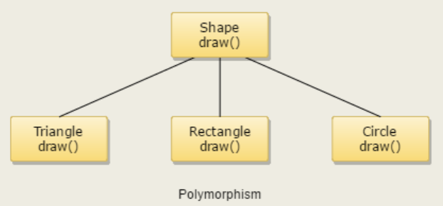

Subtype: A type defined by a child class
- Example: Triangle, Rectangle, and Circle are subclass
Supertype: A type defined by a parent class
- Example: Shape is the superclass

Signs of Polymorphism
- Overriding
- Abstract
- Instantiation

Static Binding
Also known as compile time binding. Look for a matching method signature
- Static, private, and final methods occur at compile time.
- Overloading methods is an example of static binding.
- Compile time: before running the code.

Dynamic Binding
Java uses dynamic binding, in which it locates a certain method that has the actual object’s type, not the reference type. This is during runtime.
- Used for overridden methods in polymorphisms.
- Runtime: After/during running the code.

Abstract Class
An abstract class cannot be instantiated on its own, you have to type it manually on the keyword “abstract.”
- What does it mean when a class is abstract? Must be subclassed by other classes because it cannot be instantiated.
- May contain abstract methods, no implementation. Or concrete methods with implementation.
- When to use an abstract class?
- Need class for inheritance/polymorphism.
- Use reference type
- want/need to share properties with a related class like methods or variables.

Abstract Method
- Contains only a declaration.
- Must be overridden in a subclass to be used.
- Does not need a body.
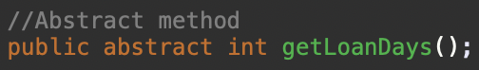

- Make an array for super class(animal) to store subclasses(tiger, hippo, cow) because animals have different data types

Abstract methods are created for the subclass

If class is “final” it cannot be inherited
If method is “final” it cannot be overridden

No constructor in interface, but when we have an interface create an instance.
____________________________________________________________________________

Module 03

Preventing Extending & Overriding
Using the “final” keyword means constant. Which prevents them from changing.
- Ex: final double PI = 3.14;

Extending
Using “final” in classes will stay the same and be prevented from changing. Meaning this prevents inheritance.
- In classes: Use final when you don’t want a class to become a parent class
- Ex: final class Song {

Overriding
Using “final” in a method means that you do not want a method to be overridden in a childclass.
(image here)

Interface
General definition: An interface is a description of how two things interact.
Java definition: An interface is a complete abstract class (100% abstract methods in a class).
- A class that contains only abstract methods.

Interfaces can contain only
- Constants
- Abstract methods
- Default and static methods

Why Use Interfaces?
To achieve abstraction/security.

- An interface tells a class what to do (interface) instead of how to do it (implementation).
- Implement multiple interfaces because in Java, a class can only extend one class.
- Interfaces allow writing different types of implementation of certain objects.

Interfaces vs. Abstract Classes
Interfaces
- Has no constructors.
- Variables must be constants (public, static, and final).
- Methods must have only a signature with no implementation (public and abstract only).

Abstract Classes
- Constructors are invoked by subclasses.
- Variables can have all types of types.
- Methods can be concrete and abstract.

The rest are the same.
Interface can extend other interfaces

Interface vs Implementation
Interface
- Describes the what
- Matched with an implementation in subclass that completes the abstraction

Implementation
- Describes the how

ArrayList
An ArrayList is a resizable/dynamic array – it can either grow or shrink the list as you add or remove elements. It’s not a normal array that you need to know the size ahead of time.
- An ArrayList is a Java class. It’s a java-util package: import java.util.ArrayList;
- An ArrayList is a generic class
- It holds a group of elements and allows you to add, remove, and access them easily.
- songs is declared as null, meaning the ArrayList points to nothing

When to Use
Use an ArrayList when
- The number of elements can change at runtime– grow or shrink
- Built-in methods for adding, removing, searching (MusicLibrary project)

Based on the other code snippet of ArrayList<Song> songs = null;
- The ArrayList starts at null
- loadSongsFromCsv picks a CSV file and reads it, then fills the list
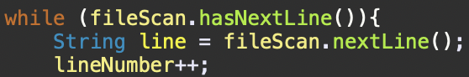
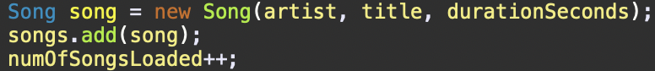
- It grows dynamically too because songs can be added in a CSV file

Collection
A collection is a group of objects (such as songs in a playlist) stored together in a list

For-Each Loop (Enhanced For Loop)
For-Each Loop is an enhanced for-loop that is simplified to iterate over collections, like an ArrayList, instead of using the index for loop.
- Best used for reading/displaying elements.
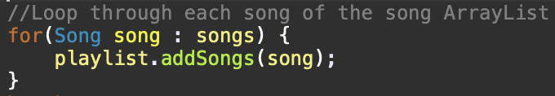
- This loop is going through each song one by one until there is no songs to be added.

Exception Handling
Exception handling is like a safety net, catches errors while the program is running and prevents unexpected crashes and can provide error messages. This manages errors smoothly and keeps the program stablelized.
- Common Java Exceptions
- IOException
- NullPointerException
- IllegalArgumentException
- ArithmeticException

Try-Catch
The Try-Catch block is what handle errors that prevents the program to crash when something unexpected happens.
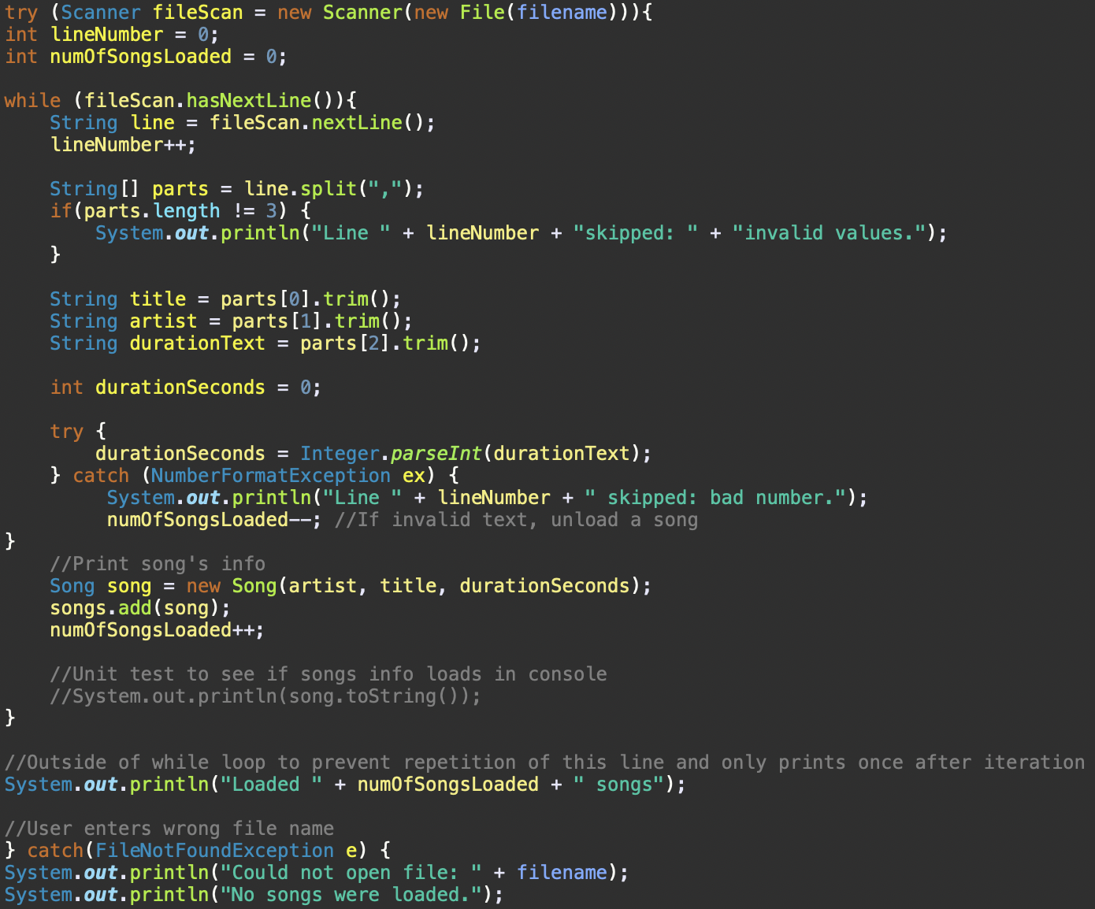
This part of the code is loading songs from a CSV file.
- The last lines of catch, if a file doesn’t exist an exception (FileNotFoundException) is thrown and gets caught by the catch block and prints out an error message instead of crashing. This has to do with the “try” from the very top reading the file lines/
- In the middle of the code, the inner try-catch checks if the song’s duration can be converted to an integer. If durationText is not a valid number, the NumberFormatException gets thrown and prints out an error message and decrement loaded songs.

Notes on Try-Catch:
- Do not use a try-catch for the whole program because it hides errors and difficult to find errors in the debugger.
- It is not always necessary to use try-catch, but when handling exceptions is necessary.
- When to use?: File I/O, network connections, database operations.

How to see try-catch block in debugger
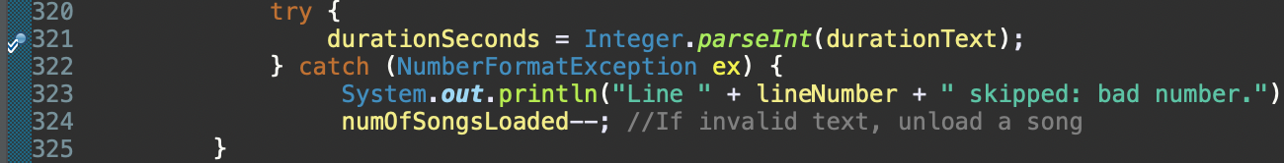
- Add break point inside the try block

Step Into Debugger Mode
| |

- Click the bug to run the debugger and press the Step Into (F5) to see what each line is doing.

Generics
A generic is a placeholder for the actual type, and the actual type is specified when creating a new object.
A generic class or method defines code with different data types safely.

Why use generics?
- Helps reuse code without duplicating and have different types while the actual type is safe.
- Doesn’t need type casting when retrieving elements.
- Supports code reusability for different data types

ArrayList
An ArrayList is a generic class that can create an ArrayList object for holding any data type.
- Includes angle brackets(<>) to be considered as a generic
- This is a generic because of the <Song>
- This ArrayList can only hold objects of the place holder: Song (data type).
- This can only apply to Song objects to add in the new ArrayList
- Without generics this would be: ArrayList songs = new ArrayList;

Linear Data Structures
Linear data structures stores elementans in sequence.
- Once we can store objects generically, we can use this method to organize them.

Each element connects to the one before and after.

Queues
Queues is First In First Out (FIFO).
- Another common data structure.
- Queue Ex: line up (First in, first out), think of multiple people lined up to buy tickets and the first person there will be out, last person there will be out last.
- Queue nodes are removed from the head(1st node) of the queue, and are inserted(added) only at the tail(last node) of the queue.
- To insert is called enqueue
- To remove is called dequeue
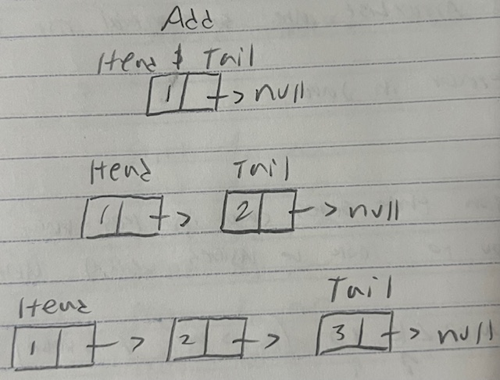
- Inserting nodes at the tail
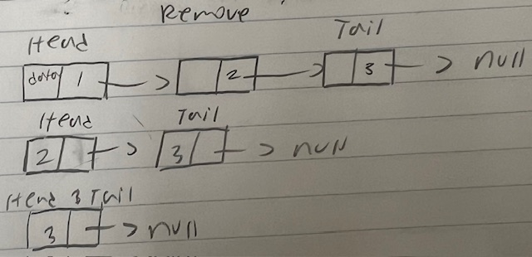
- Removing nodes at the head and declaring the other up-next nodes to be the head.

